China lightweight golf stand bag
- 14 individual full-length dividers
- Includes a cart strap pass-through, leg-lock system and cart friendly bottom
- Nine Pockets including a clothing pocket, hydration pouch, two velour-lined valuable pockets with one water-resitance, and multiple accessory pockets
- Matching rainhood included
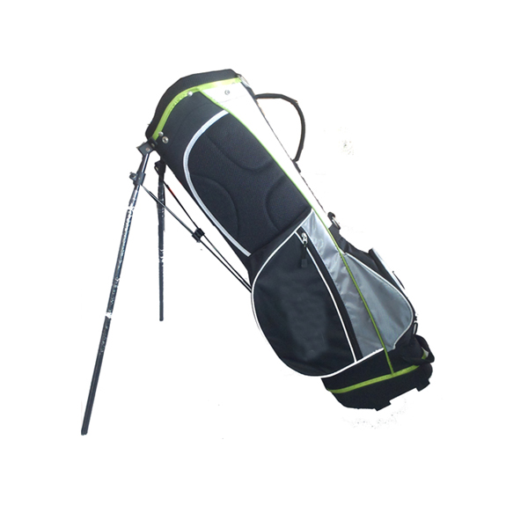
More information please click here：www.tt-golf.com

